40.45: a) We set the solutions for inside and outside the well equal to each other at the well boundaries, 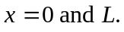
since we must have 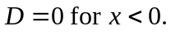
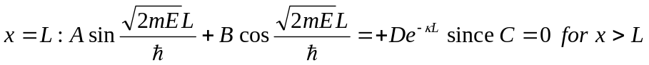
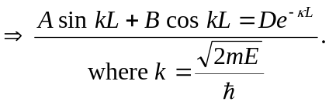
b) Requiring continuous derivatives at the boundaries yields

